To understand JOIN operations easily, think of a Cartesian product table *D* between two tables *A* and *B*. With an inner join, we select only the rows that have matching values in both *A* and *B* in *D*. With a left join, we start with the rows from the inner join and then add any additional rows from *A* to include all values of the primary key in *A*.

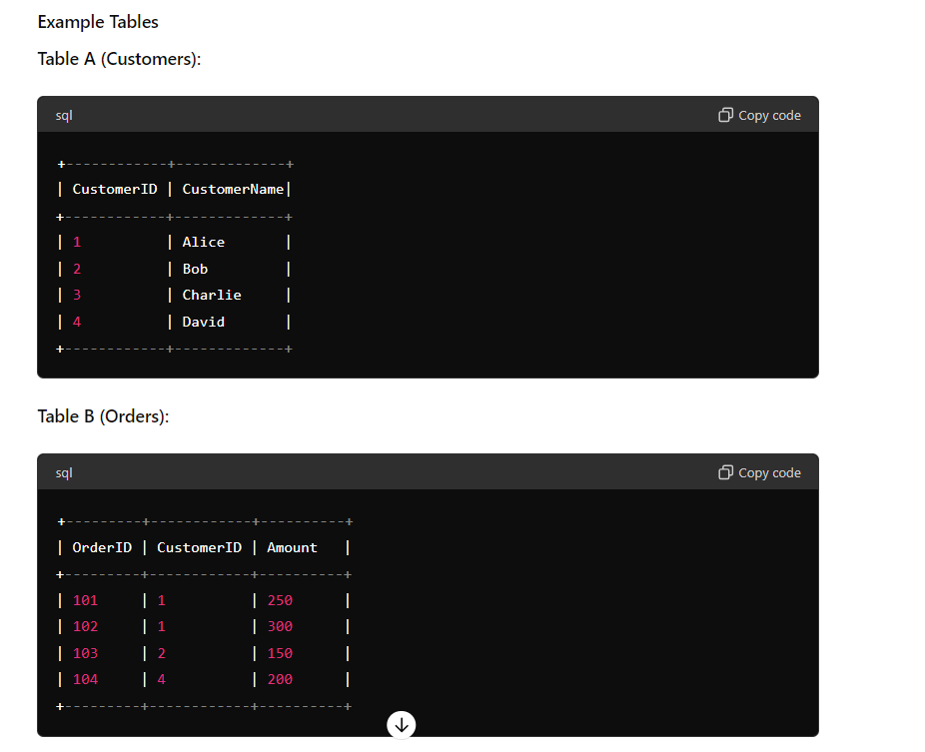

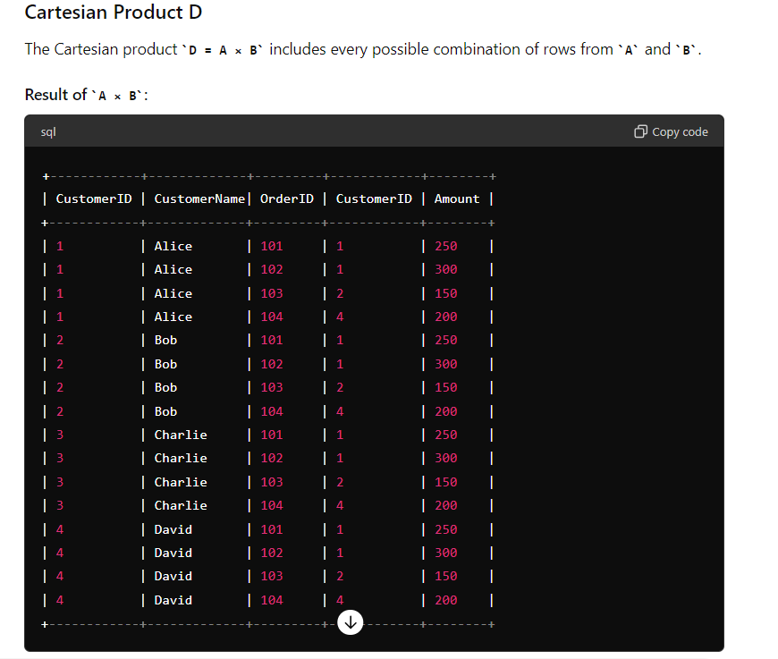

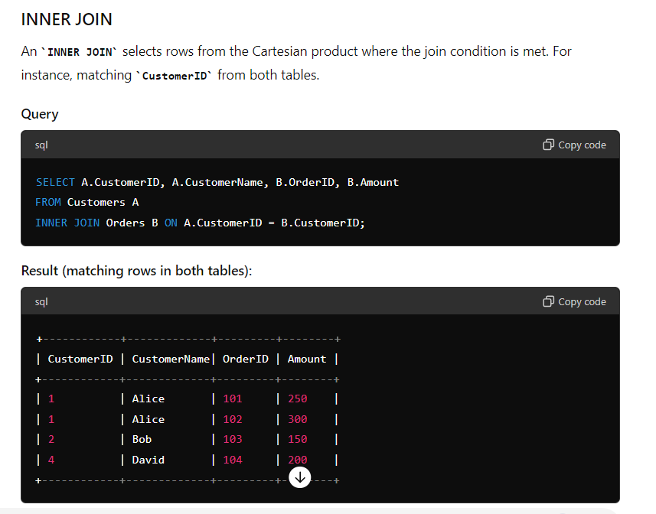

Z